**GIS410: Intro to Remote Sensing**

**Lab 7: Advanced RS Topics**

**Due: Thursday, April 15th at 11:59 PM**

**100 points**

## **PART 1: OBJECT-BASED CLASSIFICATION**

Q 1: : Explain how the spectral detail, spatial detail and minimum segment size settings are used to fine tune the image segmentation process (8 points)

**Spectral detail sets the level of importance given to the spectral differences of features in your imagery. Spatial detail sets the level of importance given to the proximity between features in your imagery. Minimum segment size is the parameter directly related to your minimum mapping unit. Segments smaller tan this size are merged with their best fitting neighbor segment. Together these parameters group pixels that are similar in color and have certain shape characteristics, by doing this you can reduce the data size and complexity of your image.**

Q 2: Describe the difference between a traditional supervised classification and the object oriented classification you ran in this exercise. (8 points)

**Object-based image classification mimics human image interpretation by using the adjacent pixel values for context when determining the class of an individual pixel. The training samples can be created using polygons or segments if you are using segmented rasters as inputs.**

**Traditional supervised classification is pixel based. Meaning that the classifications of unknown values are based off of individual pixels not the values of objects.**

Include a screenshot of your final raster for the ESRI training (5 points)

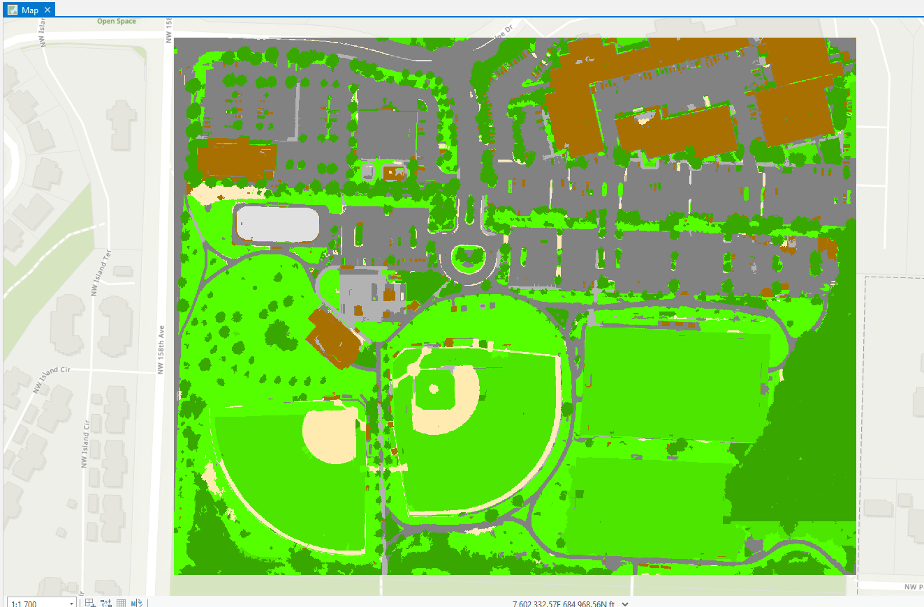

## **PART 2: WORKING WITH THERMAL IMAGERY**

Q1: How does the date of the image relate to what you see when you compare the two thermal images? (5 points)

**The June data has a higher count of high DN values than the November data. We would expect this because a higher DN value translates to warmer temperatures.**

Fill in the cells in the following table (8 points)

|  |  |  |  |  |
| --- | --- | --- | --- | --- |
|  | Minimum | Maximum | Mean | St. Dev |
| June 2009 Thermal | 1 | 211 | 131.09874 | 17.901 |
| November 2010 Thermal | 1 | 160 | 102.0988 | 6.01 |

Q2: What do the DN values represent in band 6? (5 points)

**DN shows the intensity of EM energy for the cell represented by that pixel.**

Q3: Which month has the broadest range of DN values? Why? (5 points)

**June has a higher range of DN values (1-212). This is likely because there is a wider range in temperatures experienced during June than during November, which is normally relatively similar temperatures throughout the days.**

Q4: Why does there seem to be an edge around the lakes? (5 points)

**Water sources are heat sinks, helping to equalize temperatures and prevent extreme temperatures near them.**

Fill in the cells in the following table (16 points)

|  |  |  |  |  |
| --- | --- | --- | --- | --- |
| Point | June 2009 Thermal DN Value | Temperature in degrees Celsius | November 2010 Thermal  DN Value | Temperature in degrees Celsius |
| 1 | 124 | 17.93 | 99 | 6.00 |
| 2 | 124 | 17.93 | 100 | 6.50 |
| 3 | 119 | 15.64 | 98 | 5.50 |

## **PART 3: LIDAR**

Q1: What is the resolution of the output elevation rasters? (5 points)

**10x10 feet**

Q2: What is the resolution of WMFirstRet5? (5 points)

**5x5 feet**

Q3: What are the differences in information contained in the WMDiff, Wmground and WMFirstReturn images? (10 points)

**WMGround shows the elevation from the lidar files used to create the raster, the ground LAS selection also uses only the lidar points flagged as ground points to display the LAS dataset. WMFirstReturn uses only first return first-return lidar points to display the LAS dataset.**

**WMDiff shows us the elevation of ground points and the height of building in the map frame.**

Include a screenshot of your derived hillshade image (5 points)

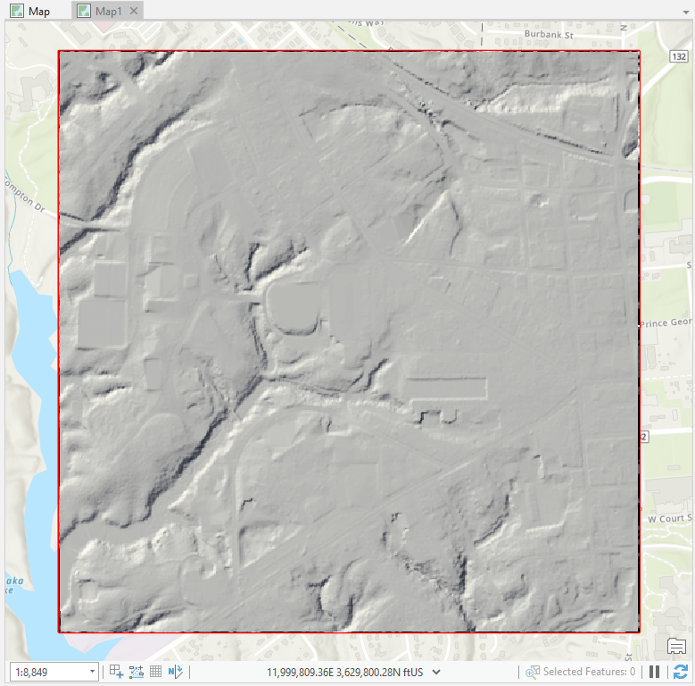

Include a screenshot of your derived slope image (5 points)

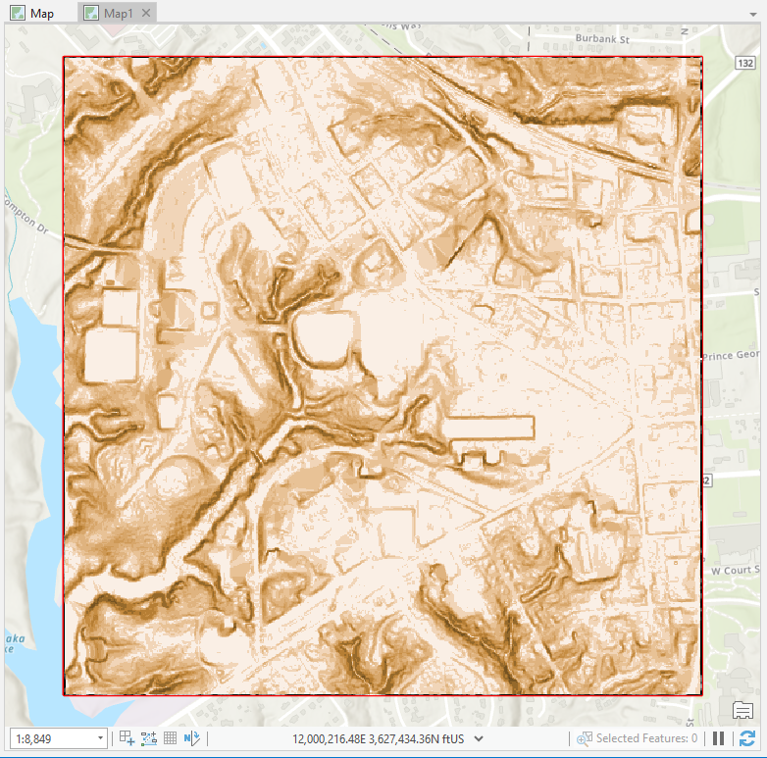

Include a screenshot of your derived contour image (5 points)

